PhishGuard
HACK-O-WEEK | WEEK 9-10
React Event Handling, Forms, and Component Design

Section 1: Title
Hack-O-Week • Week 9-10 • React Event Handling, Forms, and Component Design. This report connects the college assignment to the inspected PhishGuard source code.

Section 2: Objective
Follow the URL form event through controlled state, validation, API analysis, and composed result components.

Section 3: Theory
Events and forms. React event handlers respond to submit, click, and change. Form submission supports Enter and button activation; preventDefault avoids browser navigation.
Controlled components. A controlled input takes its value from state and updates that state through onChange. Validation can run before asynchronous work.
Composition and lifting state. A parent can compose smaller components and own state that multiple children need. Passing values and callbacks as props lifts shared state to the closest common parent.

Section 4: Implementation in PhishGuard
URLScanner is a real React form component. It owns URL, loading, error, and result state, validates a complete supported URL, and invokes the API. It composes RiskScore, ClassificationBadge, ErrorMessage, LoadingState, AnalysisBreakdown, and AnalysisDetails. App owns scan history and passes onNewResult to URLScanner; the child calls that callback with the updated history, which is an example of upward communication. App then passes history and actions down to ScanHistory.

Section 5: Code Explanation
Controlled field and submit
Source: frontend/src/components/URLScanner.jsx
Actual implementation. React state is the input value; form submission uses the event handler and the button reflects loading state. The corresponding code is in this week’s companion Code_Examples.md file.
Validation and result state
Source: frontend/src/components/URLScanner.jsx
Actual implementation. Invalid/empty values stop before the request. A valid response updates local result state and notifies the parent of history changes. The corresponding code is in this week’s companion Code_Examples.md file.
Parent state and component composition
Source: frontend/src/App.jsx
Actual implementation. App owns history shared by the scanner and history display; callbacks let children request parent-owned updates. The corresponding code is in this week’s companion Code_Examples.md file.

Section 6: Working Flow
- User enters a URL; onChange updates the controlled value.
- Form submit prevents navigation and calls handleAnalyze.
- The scanner rejects empty or malformed URLs before requesting the API.
- On success, the scanner displays composed result components and sends updated history to App.
- App passes the current records and actions to ScanHistory.

Section 7: Learning Outcome
The scanner illustrates controlled form state and event-driven validation. App lifts shared history to the common parent and uses component composition to separate the form, result panels, and history table.

Section 8: Code Implementation Screenshots
Captured from the project source file open in Visual Studio Code. Captions identify the displayed file. Code examples are in the companion Code_Examples.md file, not in this Word report. Educational examples there are labeled and are not application code.
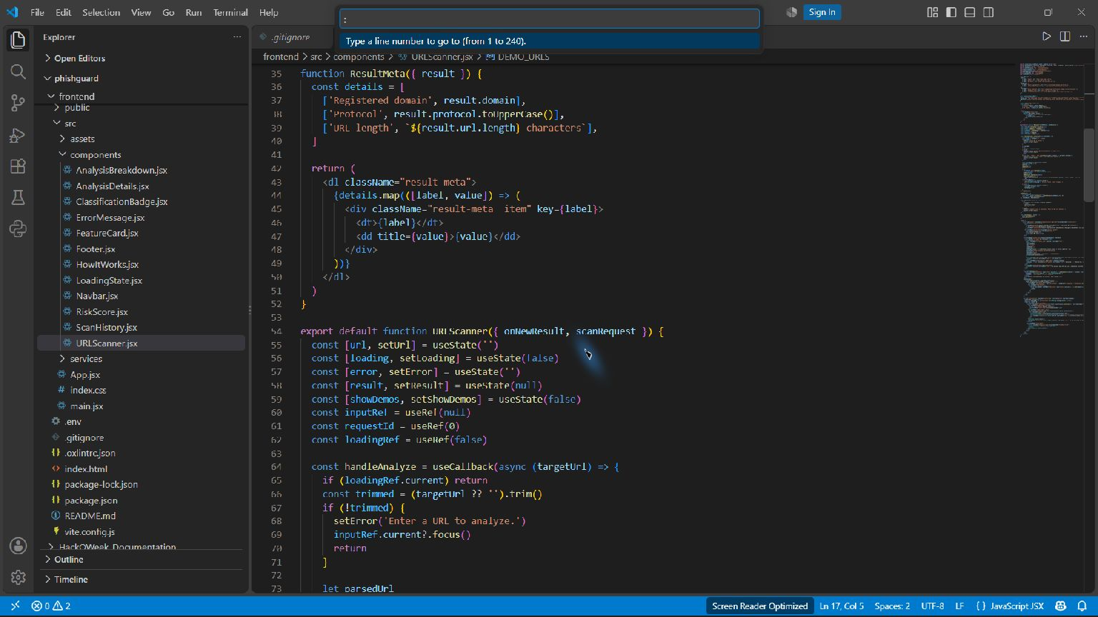
Controlled URL form and submit handler — frontend/src/components/URLScanner.jsx
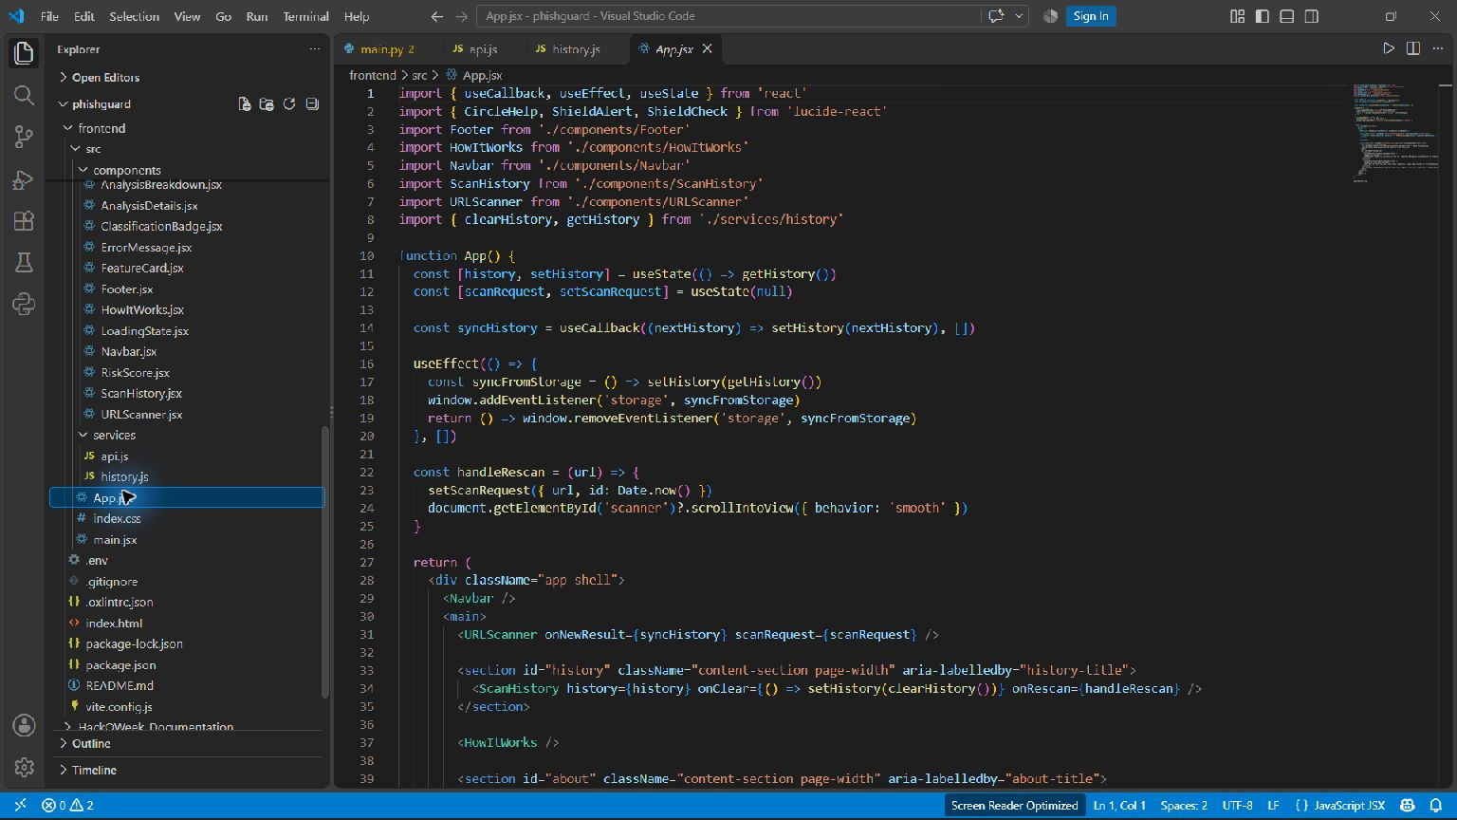
Parent state and composed child components — frontend/src/App.jsx

